**Homework #3 <update 1>**

Using the left-child right-sibling tree to implement the binomial min-heap. In your implementation, it should support the following methods:

1. getMin // return the min value of binomial heap

2. insert // insert a node into binomial heap

3. deleteMin // delete min

4. size // return the number of nodes in binomial heap

5. postorder // output the postorder traversal of the binomial heap

6. inorder // output the postorder traversal of the binomial heap

7. bHeapUnion// merge 2 binomial heap

To complete this homework assignment, you have to study the binomial heap of “Introduction to Algorithms2nd ” chapter19, and use the method in that book. For example, for *getMin()*, the nodes of root list are in increasing order by their *degrees.* When we want to find *min*, we can simply do Ɵ(*lg n*) comparisons to find the *min* without always keeping track of min value for an *n* nodes binomial heap. Do not use STL except stream and I/O.

(You should not include <string>, <vector>, <list>, <queue>, <stack>, <map>, <interator>, <algorithm>…… )

To test your program, we will input two series of integers. The first number of first series of integer is the number of elements for first binomial heap followed by the integers we want to inset into binomial heap. The first number of second series of integer is the number of elements for second binomial heap, and the following number are the integers going to be insert into the second binomial heap.

For the output, show the postorder and inorder traversal of first (bh1) and second (bh2) binomial heap. And then merge bh1 and bh2, show the postorder and inorder traversal of merge heap. After that, delete min and then show the porstorder traversal, inorder traversal, min and size of result heap.

PS: bHeapUnion should use algorithm in “Introduction to Algorithms2nd” p463, otherwise me may get different output (still is a binominal heap, but different form)

**Example for your input/output would look like:**

**Input (stdin, max integer=10000, max nodes=10000, no-repeat integer)**

//total 5 input for bh1: 4 10 2 5 7

//total 7 input for bh2: 12 8 11 6 1 9 3

5 4 10 2 5 7

7 12 8 11 6 1 9 3

**Output (stdout)**

-----------------------------------------------------------------------------------------------------------------

7 10 5 4 2

7 10 4 5 2

3 9 1 12 11 8 6

3 9 1 12 8 11 6

7 9 3 1 12 11 8 10 5 4 6 2

7 3 9 1 12 8 11 6 10 4 5 2

9 7 3 12 11 8 10 5 4 6 2

9 7 3 12 8 11 6 10 4 5 2

2

11

postorder traversal of bh1

inorder traversal of bh1

postorder traversal of bh2

inorder traversal of bh2

postorder traversal after merge bh1 and bh2

inorder traversal after merge bh1 and bh2

postorder traversal after delete min

inorder traversal after delete min

min of heap

size of heap

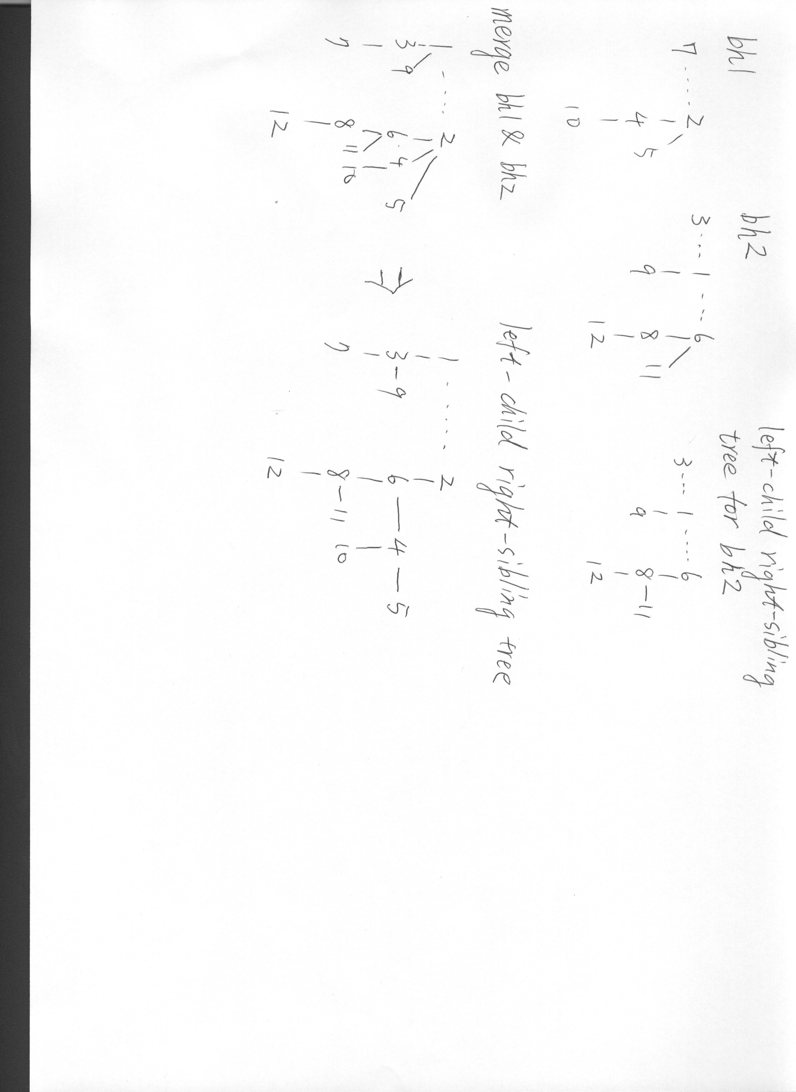

Grading

1. Program(60 points)

Step1: Correct postorder and inorder traversal for original two heaps (25 points)

Step2: Correct postorder and inorder traversal after merge two heaps (10 points)

Step3: Correct output after delete min (5 points)

Readability (20 points), if your code can’t be compiled you can get no more than 20 points.

If your output is wrong in step1, then you get 0 points in next step, so as in step 2.

If use STL others then stream and I/O you will be minus 10 points.

1. Report(40 points) ( .pdf or .doc)

Chinese or English. Less than 5 pages.

You need to hand in two files, “hw3_ID.cpp, hw3_ID.pdf” ex: hw3_0100101.cpp. (not ZIP, RAR)

You can use C++ or C (hw3_ID.c) as programing language.

The testing environment is GCC&Linux at NCTU-CS workstation (linux1.cs.nctu.edu.tw).

Alternative option is Visual studio 2008 (you should clearly mention about it in your report, otherwise you get 0 point)

Please start to finish this homework as soon as possible; there was no postponement this time.

If you have any question about this homework

please e-mail to [hans0406@yahoo.com.tw](mailto:hans0406@yahoo.com.tw) **and** [wenny0530@gmail.com](mailto:wenny0530@gmail.com)